CS 4121 **Due: 3:30pm, 10/28/19**

**GENI Lab 6: Effect of RTT and Window Size on TCP Throughput** **(21 points)**

Assumption

This worksheet assumes that you have completed all the steps listed in “GENI Lab6 Instruction”. If not, go complete them and then come back here.

Assignment Details

Part I: Data Collection **(16 points in total)**:

In this worksheet, you will compare the results of adjusting the RTT and Window Size parameters and see how they affect the TCP throughput.

Run experiments for all four combinations of two window sizes (32KB and 128KB) and two delay amounts (50ms and 150ms), take screenshots of the SSH terminals on both client and server sides, and fill up the chart below **(8 points)**. The four combinations are: 32KB and 50ms, 128KB and 50ms, 32KB and 150ms, and 128KB and 150ms.

|  |  |  |  |  |
| --- | --- | --- | --- | --- |
| Experiment | Window Size (KB) | RTT (ms) | Actual Throughput (bits/s) | Theoretical Max Throughput  (bits/s) |
| #1 | 32 | 50 | 2,180,000 | 5,120,000‬ |
| #2 | 128 | 50 |  | 409,600,000 |
| #3 | 32 | 150 | 726,000 | 1,706,666.667 |
| #4 | 128 | 150 | 3,330,000 | 6,826,666.667 |

Note:

1. Actual Window Size is **doubling** the value (16KB or 64KB) you used in the iperf command on both the client and server sides.
2. RTT is the actual Round Trip Time generated by the ping command after you added certain delay (50 ms or 150ms) to an interface through the tc command.   
     
   If the default round trip time between the client and server before adding any delay was marginal (less than 1 ms), then the actual Round Trip Time should be approximately the same as the added delay (50 ms or 150ms).
3. Actual Throughput is the Bandwidth value generated by the iperf command. If such a value is different between the client side and server side, use the smaller one.
4. Theoretical Max Throughput is the Throughput value you calculated by dividing Window Size by RTT. **Pay very special attention to the units. (i.e. KB vs MB and Byte vs bit)**
5. Remember, to change the delay on an interface, you must always first **delete** the queuing discipline and then add a new one. **(Lab6 Instructions, Part 2)**

Screenshots **(Be sure to include the terminal prompt, the relevant commands issued, and the outputs from those commands in each screenshot. No point will be assigned to any screenshot that fails to include any of them. 8 points – 1 points for each of the screenshots 1 ~ 8)**:

1. Experiment #1, server:

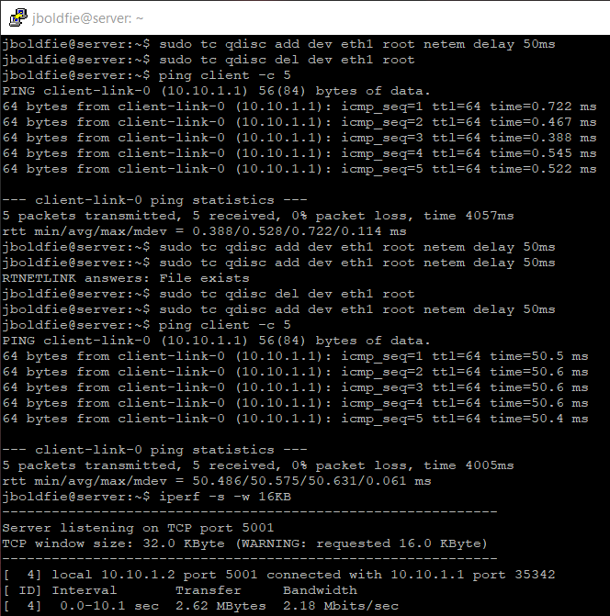

1. Experiment #1, client:

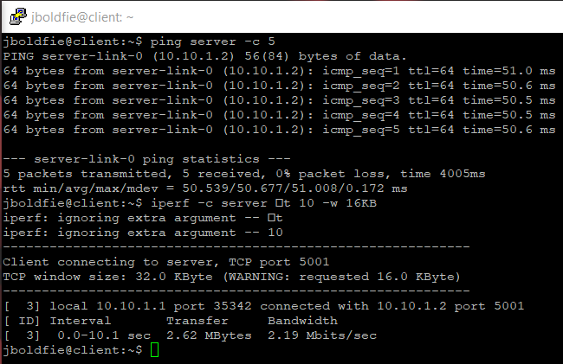

1. Experiment #2, server:

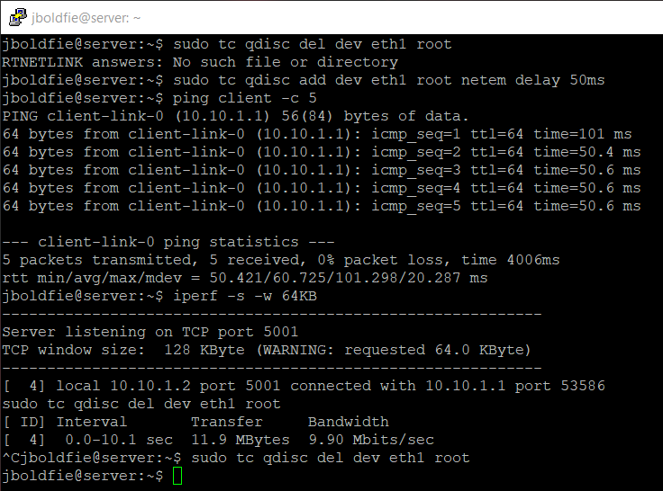

1. Experiment #2, client:

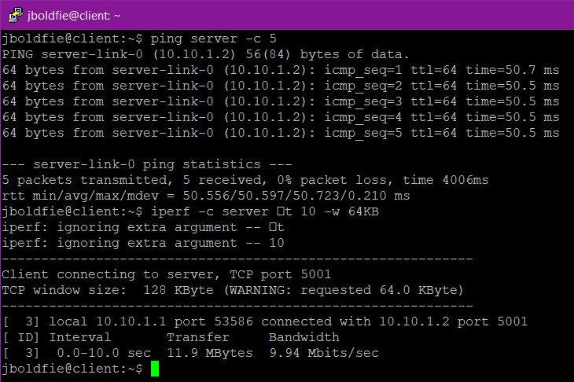

1. Experiment #3, server:

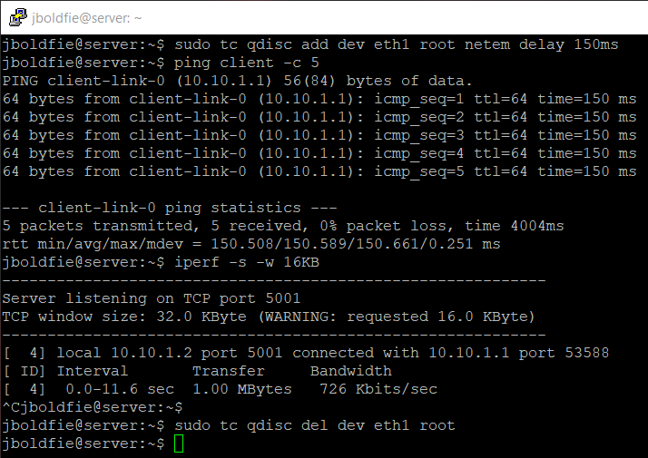

1. Experiment #3, client:

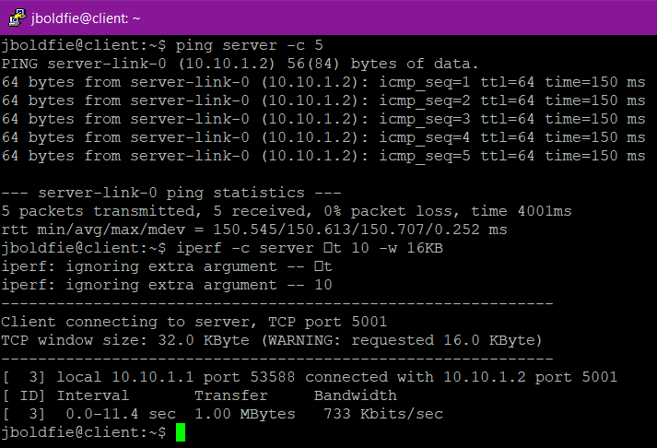

1. Experiment #4, server:

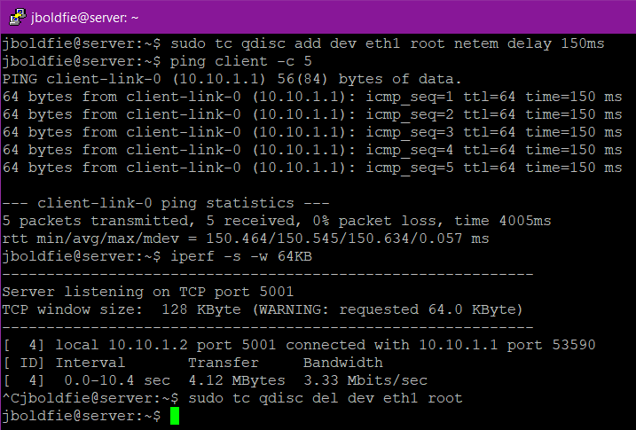

1. Experiment #4, client:

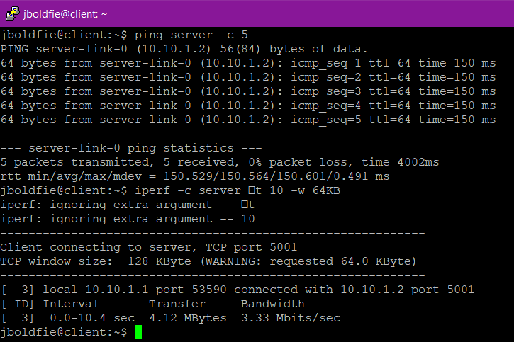

Part II: Data Analysis **(5 points in total)**:

Based on the experiments above, among the four statements below, please circle the most appropriate ones **(2 points)**:

1. While holding the TCP window size the same, the larger the RTT value, the higher the Throughput.
2. **While holding the TCP window size the same, the larger the RTT value, the lower the Throughput.**
3. **While holding the RTT value the same, the larger the TCP window size, the higher the Throughput.**
4. While holding the RTT value the same, the larger the TCP window size, the lower the Throughput.

Why? (Justify your selections above using your own words. **3 points.**)

Based on experiments #1 & #3 where Window Size stayed at 32 KB and the RTT increased from 50 to 150 ms. The actual throughput dropped from 2,180,000 to 726,000 bits/s. The actual throughput also lowered for the other two experiments. However, the theoretical max throughput for both sets increase.

When the RTT are the same and Window size increases the actual throughput increases as see by both sets of experiments of #1, #2 and #3, #4. 2,180,000 to 198,000,000 bits/s and 726,000 to 3,330,000 bits/s respectively. As do their theoretical maximum throughput.